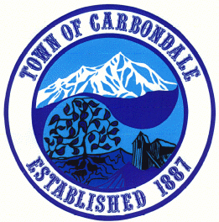
Town Of Carbondale
511 Colorado Avenue
Carbondale, CO 81623
(970) 963-2733

Requirements for Solar Installations

Building Permit fee for either system is a flat rate of $100.00. Fees for the electrical are regulated by the state.

The Town Use Tax is applicable for either system, 3.5% of ½ the valuation, due at time of permit issuance.

A contractor’s license in the Town is required.

PhotoVoltaic (PV) Systems

Solar Permit Required by the Town of Carbondale
Electrical Permit Required by the Colorado State Electrical Board, (970)947-8902

Requirements for Building Permit

1) It is required that the applicant to be certified by COSEIA or NABCEP.
2) Site Plan – Show location of home on lot and location of panels. Ground mounted to show property lines and setbacks.
3) Specification Sheets on panels and racking system. Information on snow load and wind loading required.
4) “Flush” mounted OEM Racking does not require an engineer stamp. “Tilt” mounted systems require a Colorado Licensed Engineer to design and stamp the drawings.

Thermal (Hot Water) Systems

Solar Permit required by the Town of Carbondale

Requirements for Building Permit

1) Site Plan - Show location of home on lot and location of panels. Ground mounted to show property lines and setbacks.
2) Specification Sheets on panels and racking system. Information on snow load and wind loading required.
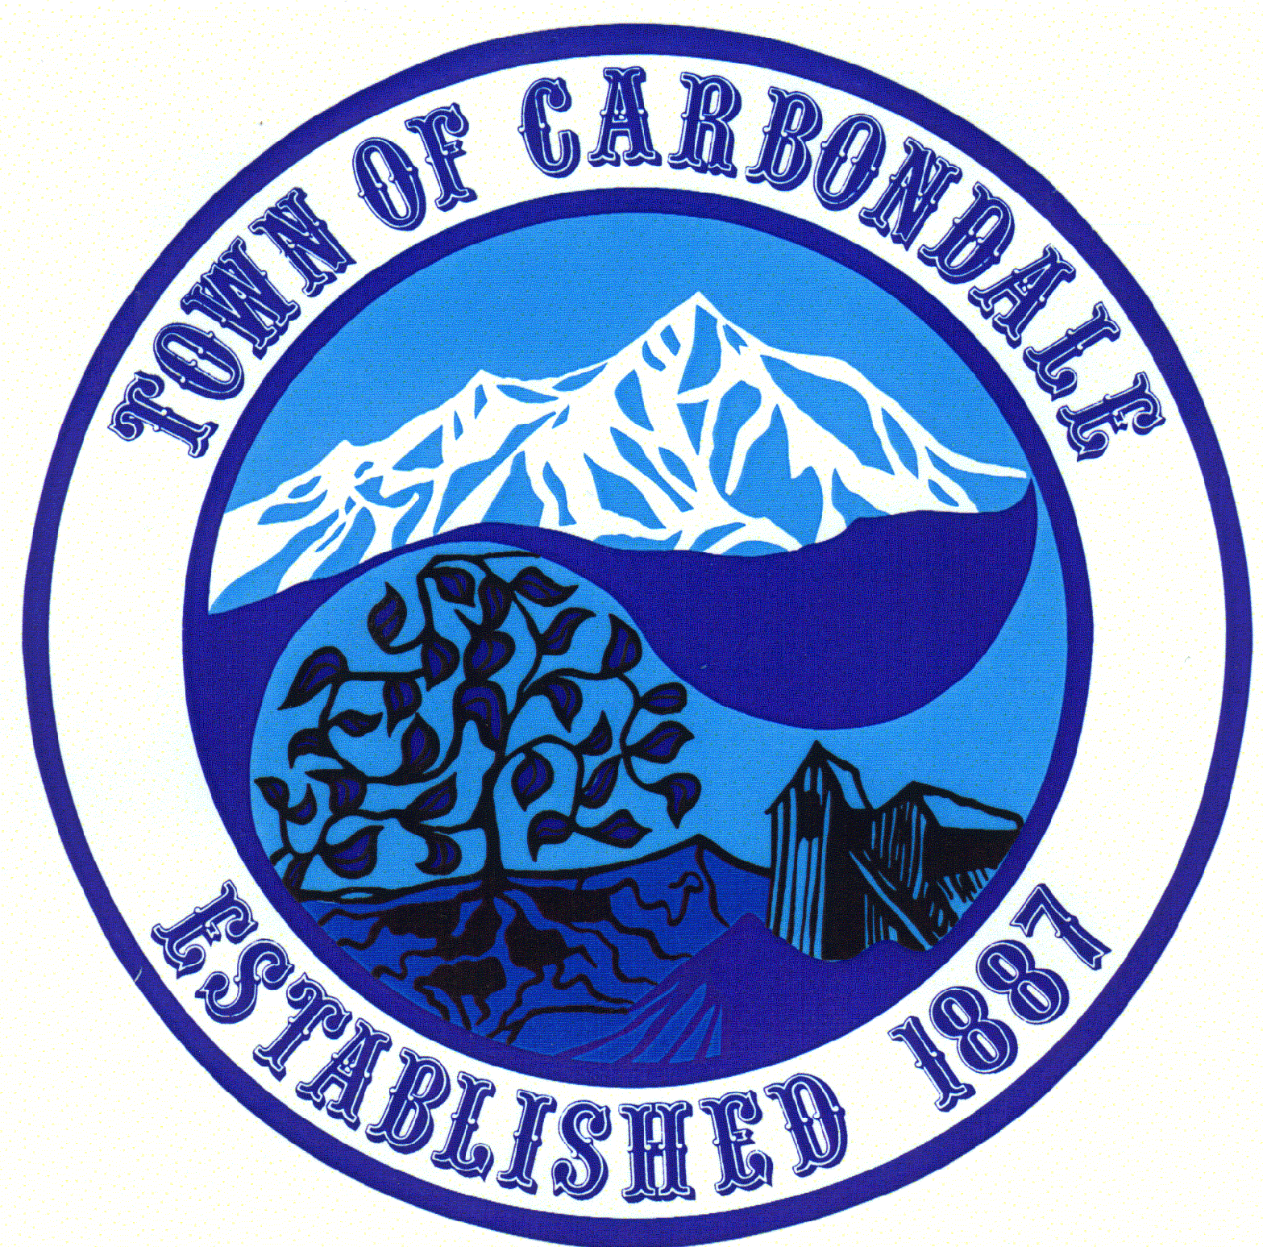
3) A Colorado Licensed Structural Engineer is required to analyze the roof structure/racking system to verify wind loads, live loads and connections are met. Supply stamped letter and/or drawings.

